always been deeply cynical about politicians.



|  |
| --- |
| **D** |

|  |
| --- |
| **damage** |

Many buildings were badly damaged during the war.  
Strong winds had caused serious damage to the roof.  
The doctors were worried that he might have suffered brain damage.  
News reports damaged the senator’s reputation.  
Fortunately, the fire caused only minor damage.

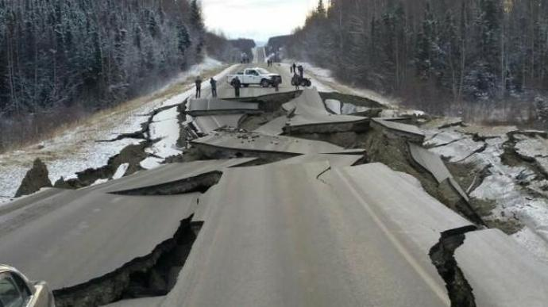

|  |
| --- |
| **danger** |

The refugees believe that their lives are in danger.  
John is still in hospital but he is out of danger.  
Firemen put their own lives in danger as part of their job.  
Most birds will warn other birds when danger threatens.  
Today’s police officers face danger every day.

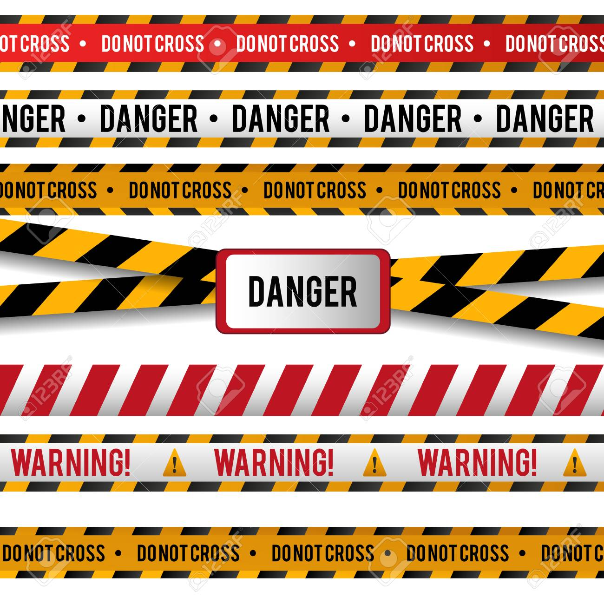

|  |
| --- |
| **dangerous** |

Some of these prisoners are extremely dangerous.  
It was a highly dangerous situation.  
The virus is probably not dangerous to humans.  
It’s dangerous for a woman to walk alone at night.

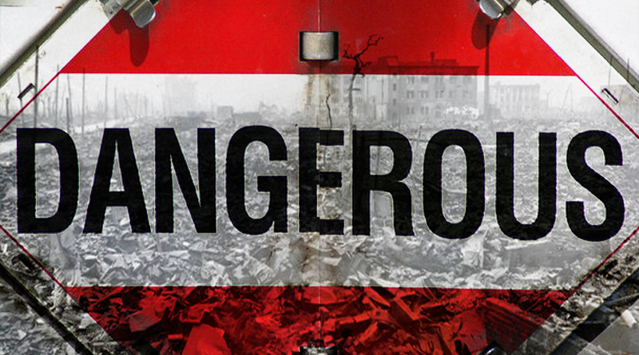

|  |
| --- |
| **darkness** |

The city was plunged into darkness by the power blackout.  
The lamp suddenly went out, leaving us in darkness.  
The room was in total darkness.  
It was late and all the houses in the village were in total darkness.  
As darkness fell, rescue workers had to give up the search.

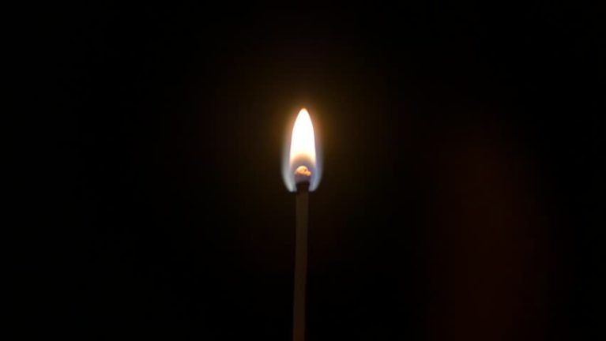

|  |
| --- |
| **date** |

What's the date (today)?/What date is it?/What's today's date?  
**uk** Today's date is 11 June (the eleventh of June).  
**us** Today's date is June 11 (June the eleventh).  
What is your date of birth?  
The expiry (us expiration) date of this certificate is August 2017.

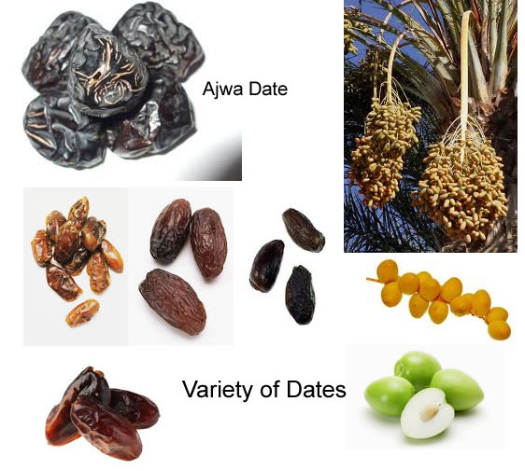

**the sweet fruit of various types of palm tree**

They dated for five years before they got married.  
How long have you been dating Nicky?



|  |
| --- |
| **deadline** |

There's no way I can meet that deadline.  
We're working to a tight deadline (= we do not have much time to finish the work).  
I'm afraid you've missed the deadline - the deadline for applications was 30 May.  
Now that the deadline is approaching we all feel under pressure.  
Do you think we will be able to meet our deadline?



|  |
| --- |
| **decrease** |

Our share of the market has decreased sharply this year.  
Total unemployment has decreased in the past year.  
There has been a steady decrease in the number of visitors.  
The country's total exports decreased by 6% in 2009.  
The number of people who have the disease has decreased significantly in recent years.



|  |
| --- |
| **dehumanize** |

***to treat people so badly that they lose their good human qualities***  
War dehumanizes people.  
Terkel says today's society has been dehumanized by technology.



|  |
| --- |
| **deliberate** |

The attack on him was quite deliberate.  
He definitely meant to be rude -- it was quite deliberate.  
We made a deliberate decision to live apart for a while.  
I didn't make a deliberate decision to lose weight. It just happened.

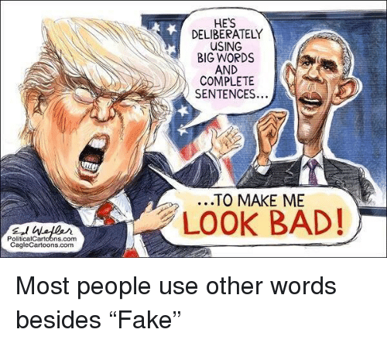

***to think or talk seriously and carefully about something:***  
The jury took five days to deliberate on the case.

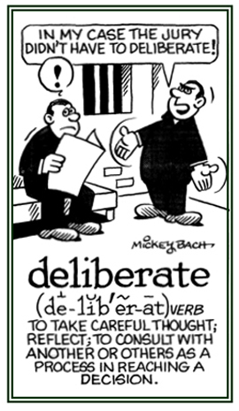

|  |
| --- |
| **democracy** |

A strong opposition is vital to a healthy democracy.  
There cannot be true democracy without reform of the electoral system.  
They carried banners demanding democracy and a free press.  
People will continue to view our party with suspicion until we display democracy within our organization.



|  |
| --- |
| **demonstrate** |

The study demonstrates the link between poverty and malnutrition.  
He has demonstrated the ability to meet deadlines.  
These numbers clearly demonstrate the size of the economic problem facing the country.  
The teacher demonstrated how to use the equipment.



|  |
| --- |
| **demonstration** |

Let me give you a demonstration of how the camera works.  
He gave us a demonstration of the new software in use.  
The rise in unemployment is just another demonstration of the government's incompetence.

The students are holding a demonstration against the proposed changes.

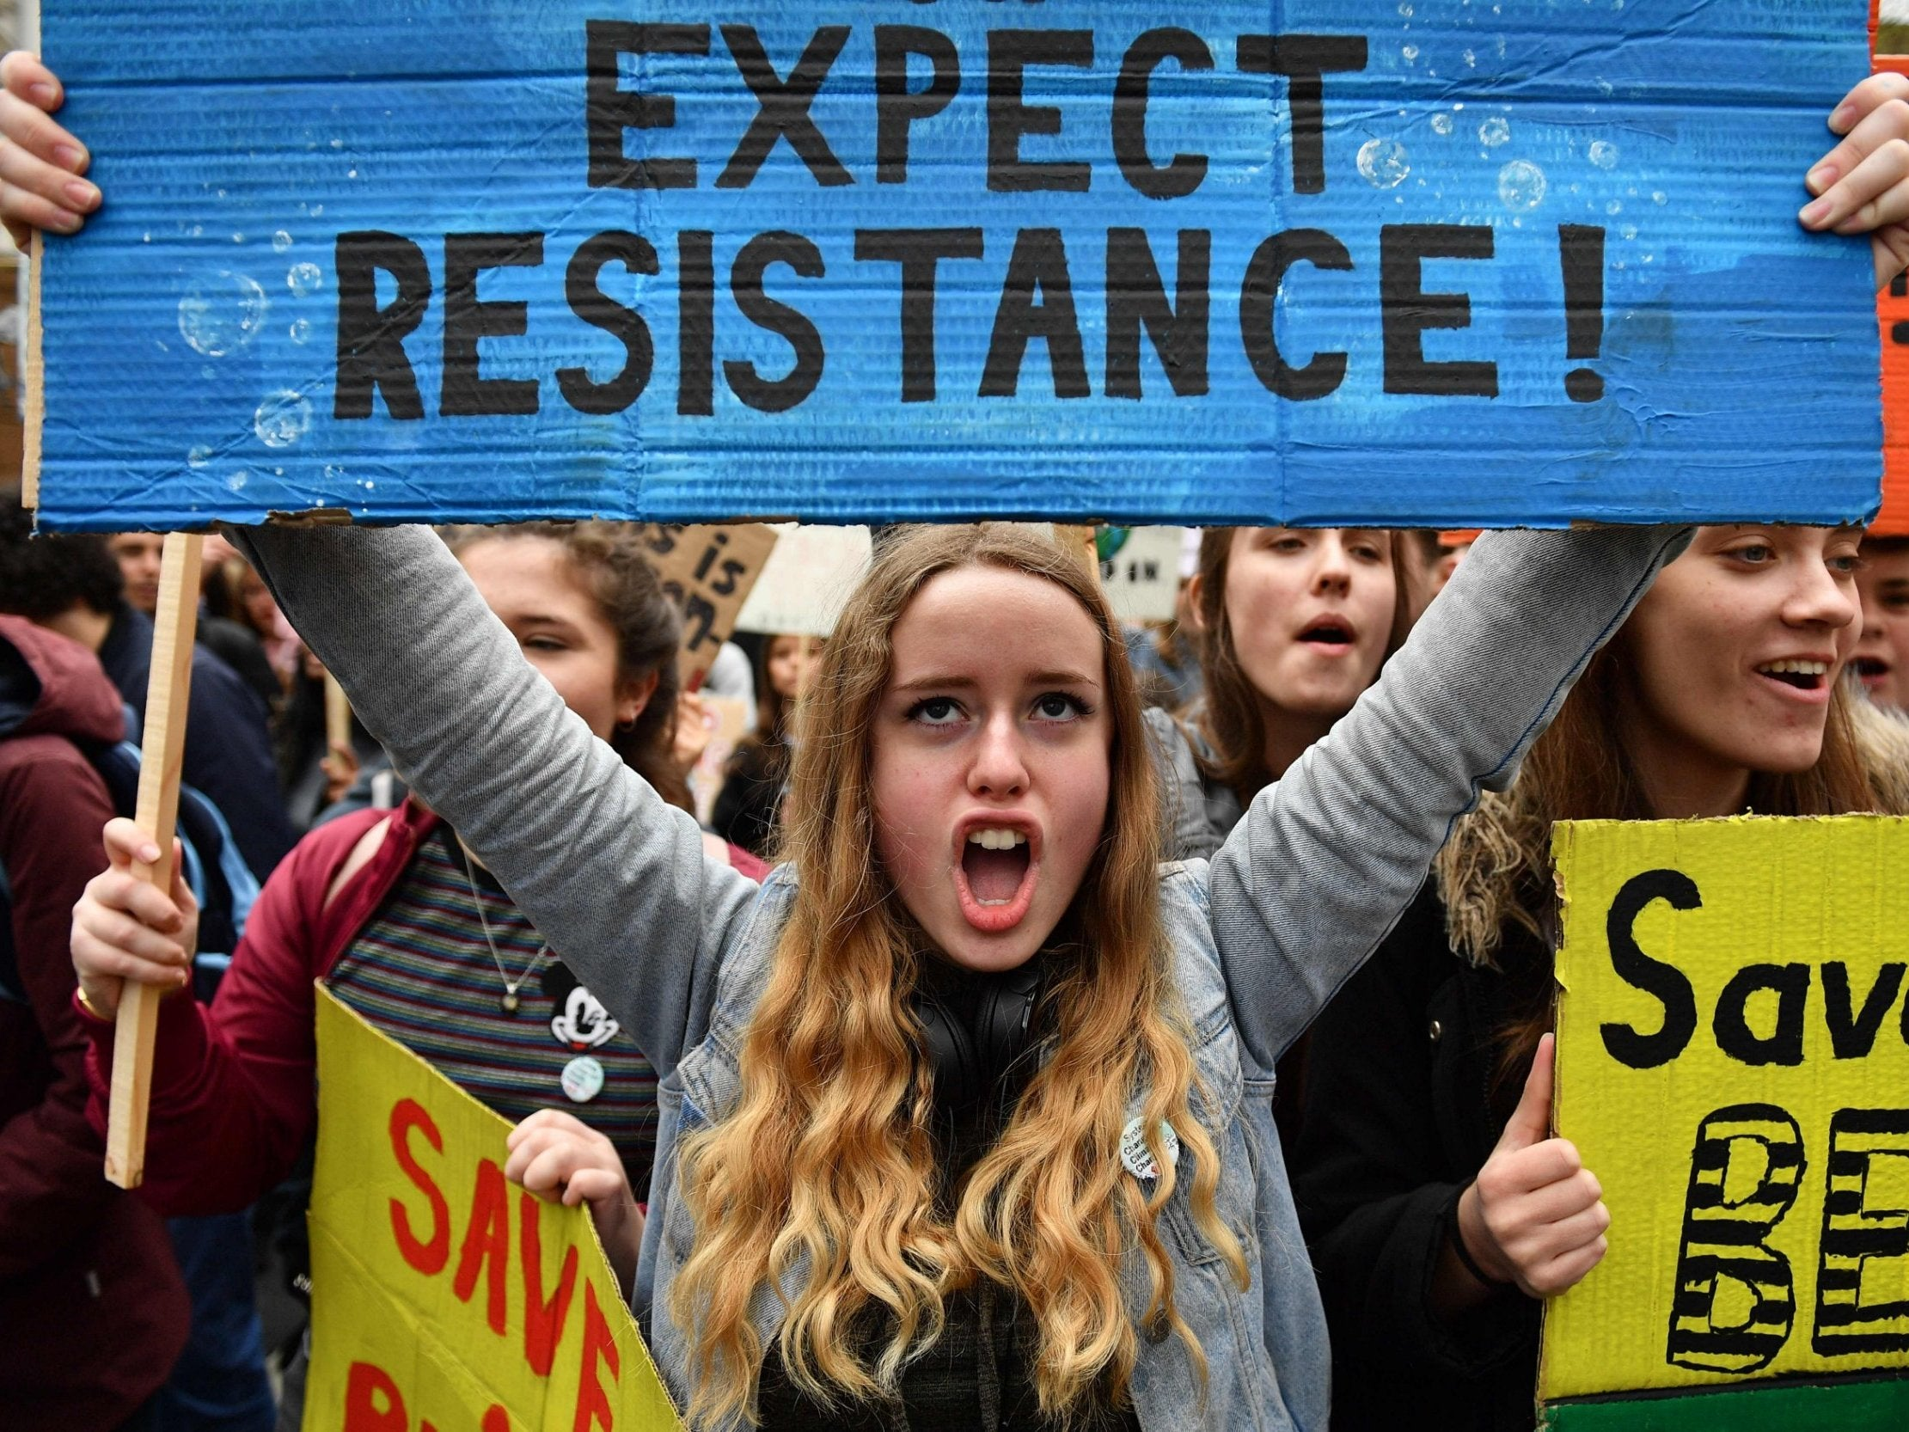

|  |
| --- |
| **deploy** |

***to move soldiers or equipment to a place where they can be used when they are needed:***  
The decision has been made to deploy extra troops/more powerful weapons.  
NATO’s decision to deploy cruise missiles.  
UN troops were deployed to keep the peace.

The Chief of Police ordered the **deployment** of 300 troops to try to stop the rioting.



|  |
| --- |
| **depression** |

She suffers from periods of deep depression, when she locks herself away and will speak to no one for weeks.  
He has been suffering from depression since his wife died last year.  
During the past few decades, prescription drugs have also been widely used to control the symptoms of depression.  
If you suffer from depression, it's best to get professional help.

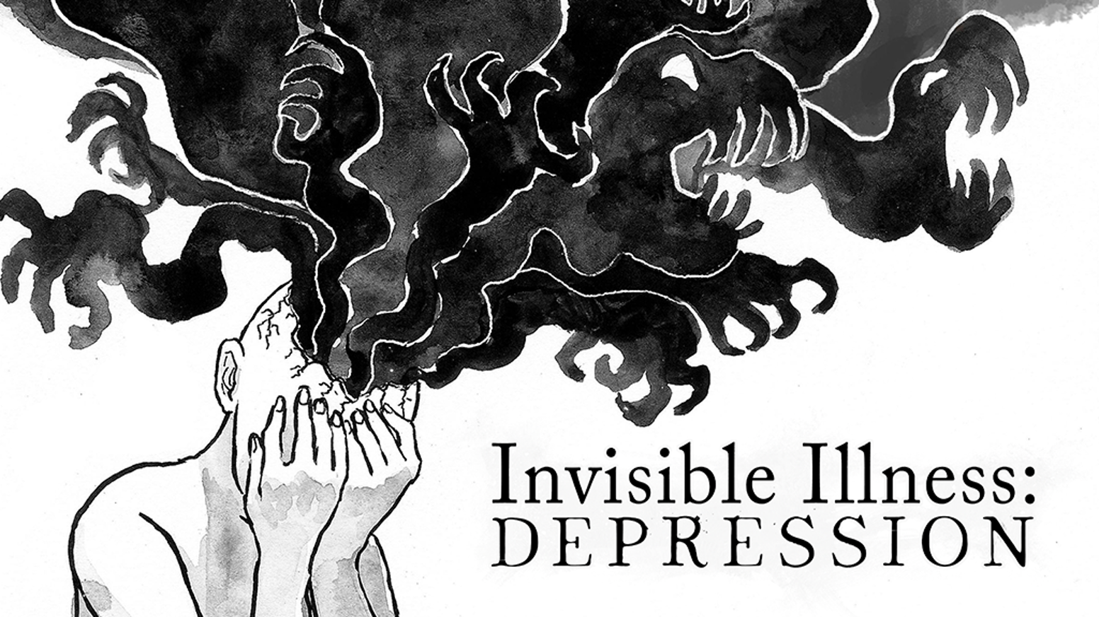

|  |
| --- |
| **designate** |

***to choose someone officially to do a particular job:***  
Traditionally, the president designates his or her successor.  
Thompson has been designated (as/to be) team captain.  
She has been designated to organize the meeting.

[caption id="attachment_9864" align="alignnone" width="800"]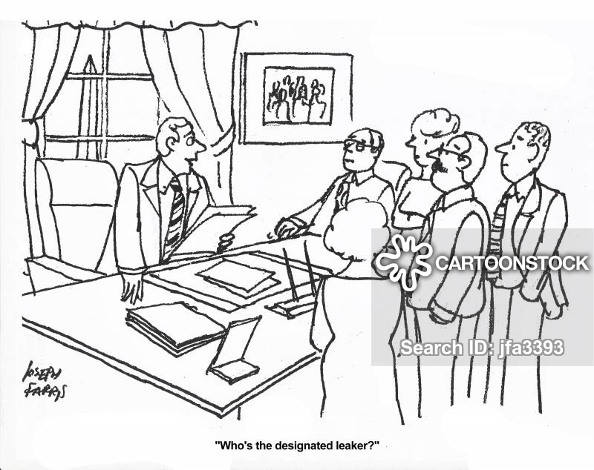 'Who's the designated leaker?'[/caption]

***to say officially that a place or thing has a particular character or purpose:***  
This area of the park has been specially designated for children.  
The lake was recently designated a conservation area.

|  |
| --- |
| **desperate** |

The situation is desperate - we have no food, very little water and no medical supplies.  
The earthquake survivors are in desperate need of help.  
I had no money left and was desperate.



|  |
| --- |
| **destructive** |

I worry about the destructive effect that violent films may have on children.  
Lack of trust is very destructive in a relationship.  
Jealousy is a very destructive emotion.

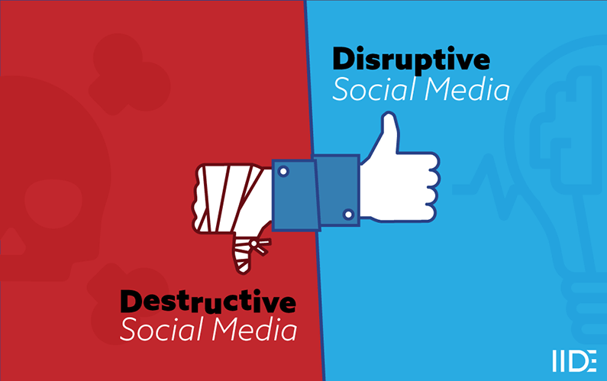

|  |
| --- |
| **detain** |

***to officially prevent someone from leaving a place***  
Two suspects have been detained by the police for questioning.  
She was detained in hospital with a suspected broken leg.  
A suspect is being detained by the police for further questioning.

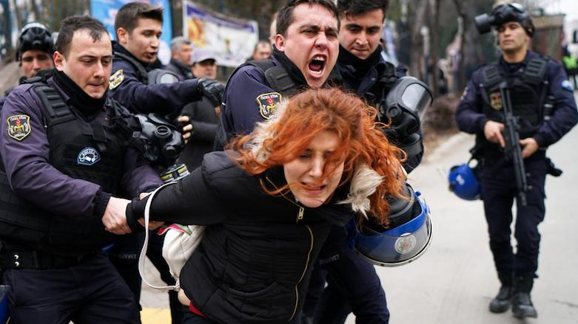

|  |
| --- |
| **determine** |

Your health is determined in part by what you eat.  
Eye colour is genetically determine.  
People should be allowed to determine their own future.  
On leaving jail, Joe determined to reform.  
The police never actually determined the cause of death.  
Investigators are still trying to determine the cause of the fire.

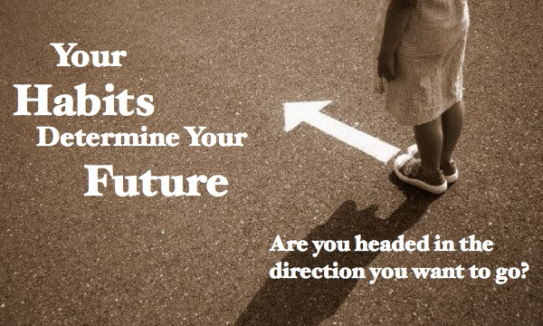

|  |
| --- |
| **determinant** |

***something that controls or affects what happens in a particular situation:***  
Soil and climate are the main determinants of how land is used.  
Social class is a major determinant of consumer spending patterns.  
What are the determinants of supply?

|  |
| --- |
| **diligent** |

Leo is very diligent in/about his work. *(careful and using a lot of effort:)*  
Their lawyer was extremely diligent in preparing their case.  
The discovery was made after years of diligent research. *(done in a careful and detailed way:)*



|  |
| --- |
| **diminish** |

I don't want to diminish her achievements, but she did have a lot of help.  
These memories will not be diminished by time.  
What he did has seriously diminished him in many people's eyes.  
We've seen our house diminish greatly/sharply/substantially in value over the last six months.  
Later on in life the sex drive tends to diminish.

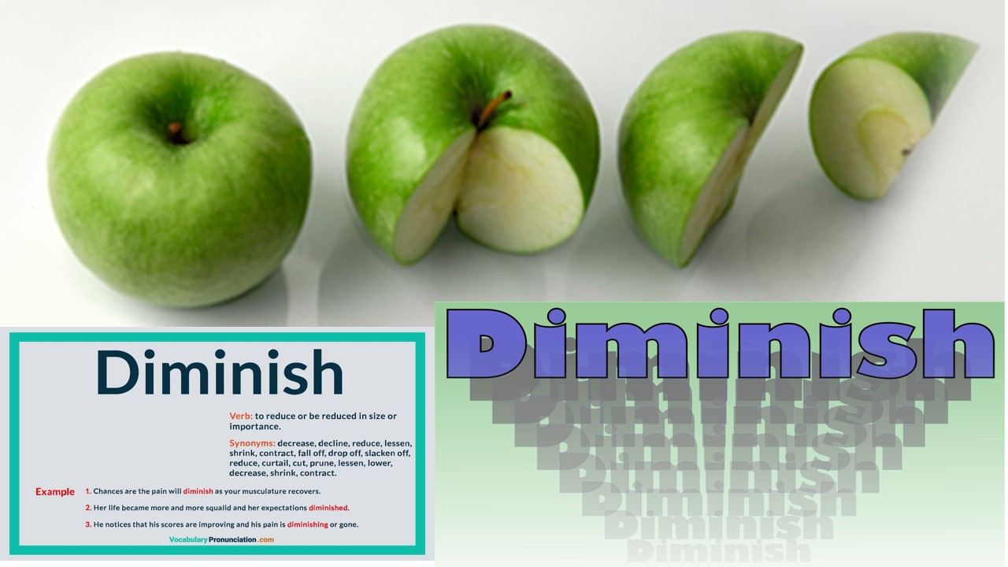

|  |
| --- |
| **disaster** |

In recent years there has been an increase in weather-related natural disasters.  
This region is facing an ecological disaster as a result of toxic waste.  
200 people died in the train disaster.  
The earthquake was the worst natural disaster to hit India for over 50 years.

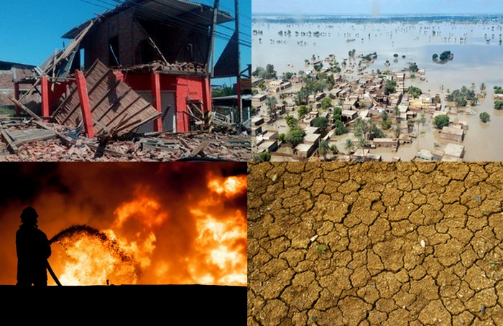

|  |
| --- |
| **disorder** |

Everything was in disorder, but nothing seemed to be missing.  
The whole office was in a state of disorder.  
He was diagnosed with a severe psychiatric disorder.  
Eating disorders can be very difficult to treat.  
The study suggested that 84% of prisoners have a personality disorder.  
a mental/physical disorder

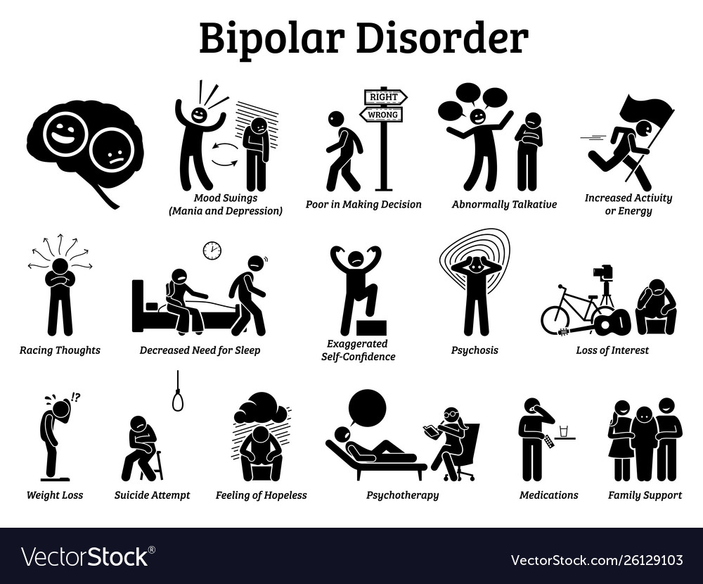

|  |
| --- |
| **disperse** |

***to spread across or move away over a large area, or to make something do this:***

When the rain came down the crowds started to disperse.  
Police dispersed the crowd that had gathered.  
Debris from the aircraft was dispersed over a large area.  
Once the seeds are released into the air, the wind quickly disperses them.



|  |
| --- |
| **displace** |

The building of a new dam will displace thousands of people who live in this area.  
Millions of people who were displaced will need shelter, food and clothing.  
Coal has been displaced by natural gas as a major source of energy.

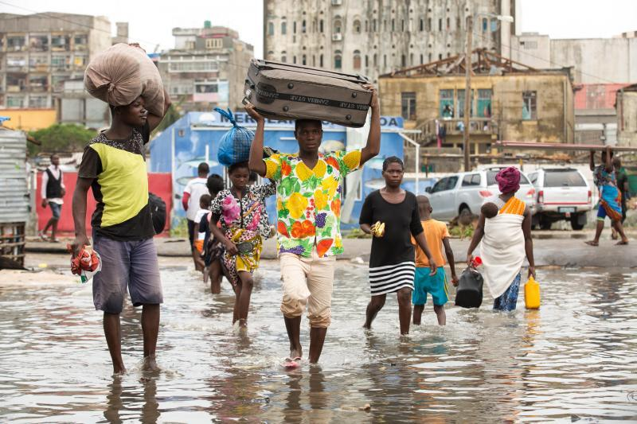

|  |
| --- |
| **dispose of** |

***to get rid of something, especially by throwing it away:***

The agency has put an end to new efforts to dispose of hazardous waste in sensitive environmental areas.  
Nuclear waste can cause serious damage to the environment if not disposed of properly.

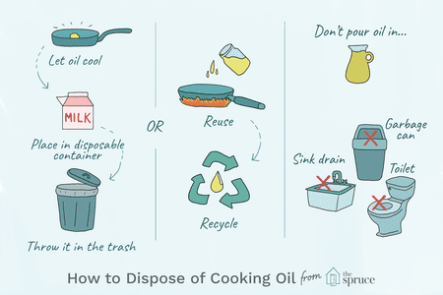

|  |
| --- |
| **disruptive** |

***changing the traditional way that an industry operates, especially in a new and effective way:***  
disruptive technologies

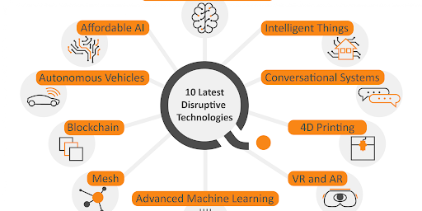

***tending to damage the orderly control of a situation:***  
***causing problems and preventing something from continuing in its usual way.***  
The teacher said disruptive behavior would not be tolerated  
Night work can be very disruptive to home life.



|  |
| --- |
| **distant** |

She could hear the distant sound of fireworks exploding.  
At some point in the distant future, I would like to have my own house.  
She heard the wind whistling through the trees and the howl of a distant wolf.  
The president hopes to visit Ireland in the not too distant future (=quite soon).

  
After the quarrel, Sue remained cold and distant.  
I don't get mad, I get distant.



|  |
| --- |
| **distinction** |

There's a clear distinction between the dialects spoken in the two regions.  
This company makes no distinction between the sexes.

***In written English, people often use to draw a distinction rather than make a distinction, because it sounds more formal:***

It's sometimes very difficult to draw a clear distinction between the meanings of different words.  
The law draws a distinction between temporary and permanent employees.



|  |
| --- |
| **distinguished** |

used to describe a respected and admired person, or their work:  
a distinguished writer/director/politician  
He quit his job at Cornell, ending a distinguished academic career.  
Ms. Dixon comes from a distinguished Washington family.



|  |
| --- |
| **distress** |

***a feeling of extreme worry, sadness, or pain:***

She claimed that the way she had been treated at work had caused her extreme emotional and psychological distress.  
Many of the horses were showing signs of distress at the end of the race.

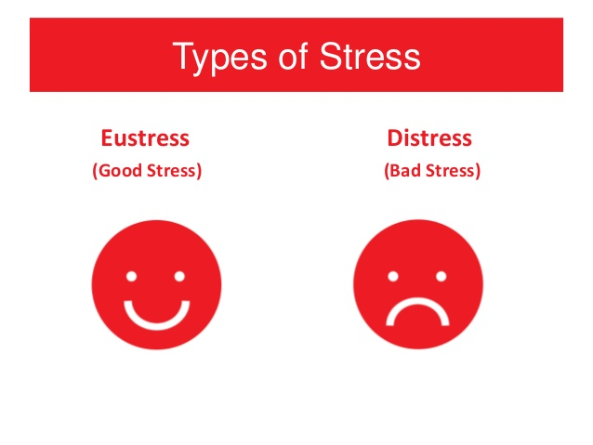

***Stress is simply the body's response to changes that create taxing demands. The previously mentioned Dr. Lazarus (building on Dr. Selye's work) suggested that there is a difference between eustress, which is a term for positive stress, and distress, which refers to negative stress.***

***a situation in which you are suffering or are in great danger and therefore in urgent need of help:***

Six people were rescued by helicopter from a fishing boat in distress off the coast.

|  |
| --- |
| **distressing** |

The front-page news was shocking and distressing.  
Being in a strange city with no money was an extremely distressing situation.  
It is very distressing to find out at a later date that you have made a mistake which can cost you dearly.

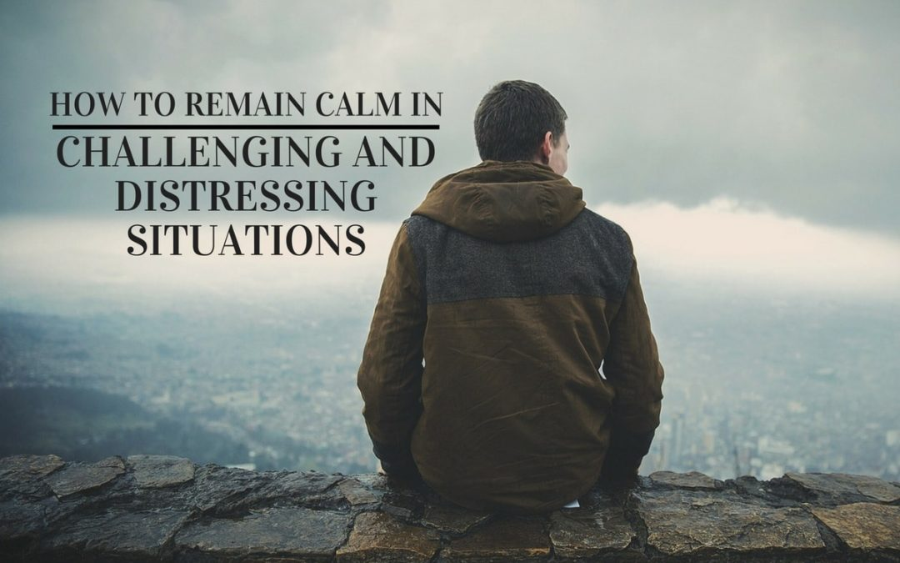

|  |
| --- |
| **diverse** |

İstanbul is a very culturally/ethnically diverse city.  
We hold very diverse views on the topic.  
There is a diverse range of opinions on the issue.

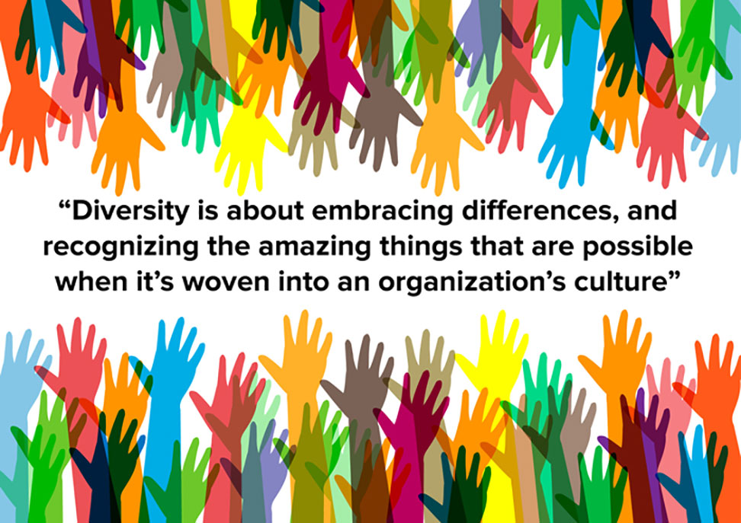

|  |
| --- |
| **diversity** |

***Diversity****is defined as the****differences****between people.****Diversity****can be real or perceived****differences****between people. These****differences****include but are not limited to race, gender, sexual orientation, religion, and socioeconomic status.*

Does television adequately reflect the ethnic and cultural diversity of the country?  
There is a wide diversity of opinion on the question of unilateral disarmament.  
She teaches the students to have respect for different races and appreciate the diversity of other cultures.

|  |
| --- |
| **domestic** |

The domestic market is still depressed, but demand abroad is picking up.  
Focusing on exporting can help fight off domestic and foreign competition.  
Domestic flights (=flights that stay inside a particular country) go from Terminal 1.  
The president’s foreign and domestic policies have been criticized.



|  |
| --- |
| **dragon** |

***a large, fierce, imaginary animal, usually represented with wings, a long tail, and fire coming out of its mouth***



|  |
| --- |
| **E** |

|  |
| --- |
| **emerge** |

***to appear by coming out of something or out from behind something:***  
She emerged from the sea, blue with cold.  
The sun emerged from behind the clouds.  
The runway lights flashed on, and the first models emerged from behind the stage set.  
No definitive results have yet emerged from the discussions.



|  |
| --- |
| **emergency** |

The staff need to know what to do in an emergency.  
In case of emergency, press the alarm button.  
The plane had to make an emergency landing.  
The government called an emergency meeting to discuss the crisis.  
Do you think that you could cope with an emergency?



|  |
| --- |
| **empirical /empirikıl/** |

*based on what is experienced or seen rather than on theory:*  
This theory needs to be backed up with solid empirical data/evidence.  
Empirical studies show that some forms of alternative medicine are extremely effective.